Console Client by Melanie Thielker
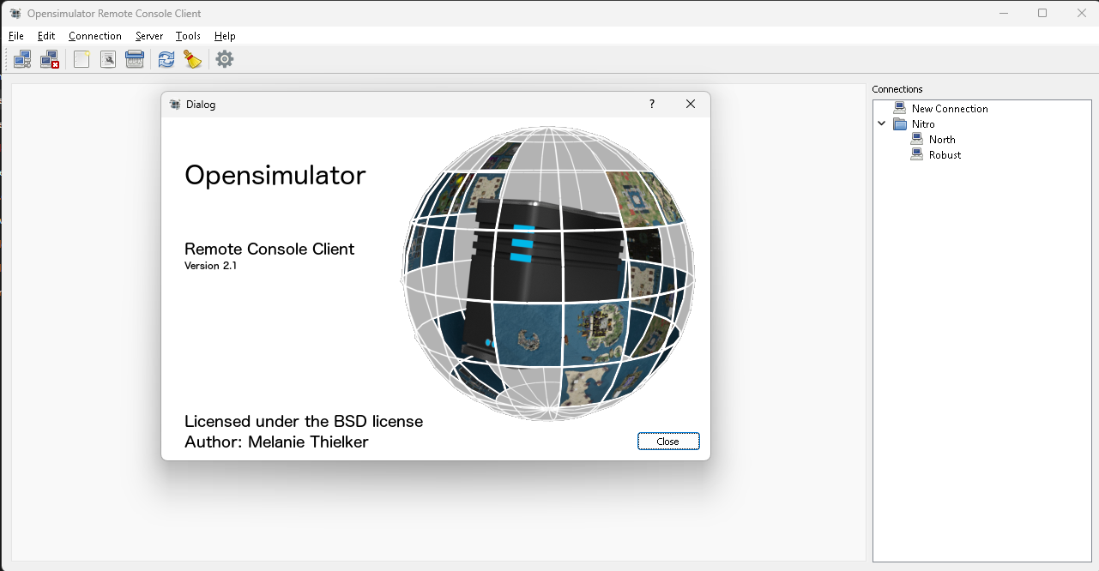
Runs on windows or Mac
Console for Robust (Grid) and Regions. DreamGrid bundles a copy in the ConsoleClient folder; open it with Settings -> Console -> Console Client -> Open Console.

Source: http://opensimulator.org/wiki/OpenSimConsoleClient
Windows: http://opensimulator.org/downloads/ConsoleClient.zip
Mac: http://opensimulator.org/downloads/ConsoleClient.dmg
Src: https://github.com/MelanieT/OpenSimConsoleClient

